Dan Crisp

Professor LAM!

IAH 207: Monstrosity, All About It

March 29, 2018

Title: Subtitle

Jeffrey Jerome Cohen’s work, “Monster Culture”, describes seven theses that aid in the discussion of monstrosity. Here, we’ll focus on the fourth of seven with the longhand, ‘The Monster Dwells at the Gates of Difference’. It goes on to describe

In David Cronenberg’s 1986 remake of the film The Fly, the protagonist Seth Brundle is a scientist who invents a way to teleport inorganic—then organic—matter from one ‘telepod’ to another. Everything goes horribly wrong when he attempts to teleport himself but gets genetically assimilated with a fly that had wandered into the teleporter with him. In time he morphs both physically and mentally into that of a horrific fly-like humanoid, but before it becomes apparent how physically abject his body is going to get, there’s an instructive 8-minute sequence where we’re shown ways in which Seth is becoming increasingly different. Starting at about 41 minutes in, we see him perform an impressive gymnastics routine that showcases his extraordinary fitness that ends in shared looks of awe by both Veronica and himself. Then at 44 minutes in, you see them both visiting a coffee shop on holiday. It’s apparent he’s losing impulse control as he exhibits compulsive talking to the point of talkaholism. At about 45:30 minutes, Veronica is exhausted from what appears to have been a fairly lengthy marathon of sex, she can no longer satisfy his libido. Finally, at 47 minutes in, his impulsiveness and agitation begins to culminate as he attempts to force Veronica to try teleportation for herself, and rants madly about his mythic level of wisdom in an interesting reference to Alexander Pope’s “An Essay on Criticism”. Illustrations of his alterity continue but become less subtle and intertwined with a visibly abject physical state. It’s clear from this sequence that there is a limit to what is considered normal in terms of physical strength, self-control, sexual appetite, and social etiquette: Seth Brundle, or ‘Brundle-fly’, is clearly outside of those culturally understood limits. It is this difference from cultural norms that defines brundle-fly’s monstrosity as much as it does the norms themselves. This is what Cohen meant by dwelling at the gates of difference, brundle-fly’s monstrosity exists at the opposing end of these differences.

Franz Kafka’s Metamorphasis is another work which allows us to use Cohen’s fourth thesis to understand difference as a form of monstrosity. The protagonist Gregor, wakes up one day to find himself changed into something that re

Research papers that use MLA format do not include a cover page unless requested by your instructor. Instead, start with the information shown at the top of this page. Do not bold the title or use all capital letters. Capitalize the first and last words of the title, and all principal words. If your paper includes a subtitle, separate it from the title by a colon and space, as shown. For more specific guidance on capitalization, see the MLA Handbook for Writers of Research Papers, 7th Edition (MLA 7th Edition).

All text—including titles, quotations, notes, and list of works cited—uses double line spacing. Body text and note text use a half-inch first-line indent. The list of works cited uses a half-inch hanging indent. Table titles and source text use a quarter-inch indent. Access all of these text formats on the Home tab, in the Styles gallery.

MLA format discourages extensive use of content notes. But, when you need to add notes, you can use either endnotes or footnotes. MLA 7th Edition indicates that you should use a superscript, Arabic numeral at an appropriate place in the text for the note reference. To begin the note text, use the same numeral, not superscript, and followed by a period.

If you use endnotes, they should be on a separate page, at the end of your text and preceding the list of works cited. If you use footnotes, consult your professor for preferred format.

For quotations of more than four lines, indent the quote one inch from the left margin and do not use quotation marks. To apply this formatting, on the Home tab, in the Styles gallery, click Quote. For shorter quotations, you can put them in quotation marks and incorporate them directly into text.

Table 1

This Table Title Uses a Style Named “Table Title”, Available on the Home Tab, in the Styles Gallery

| Column Heading | Additional Column Heading | Additional Column Heading | Additional Column Heading |
| --- | --- | --- | --- |
| Row heading | Table text | Table text | Table text |
| Row heading | Table text | Table text | Table text |
| Row heading | Table text | Table text | Table text |

Source: This source text uses a style named “Table Source”, available on the Home tab, in the Styles gallery.

1. This note text uses a style named “Table Note”, available on the Home tab, in the Styles gallery. Table notes use a lowercase letter instead of Arabic numerals to differentiate them from the notes to body content.

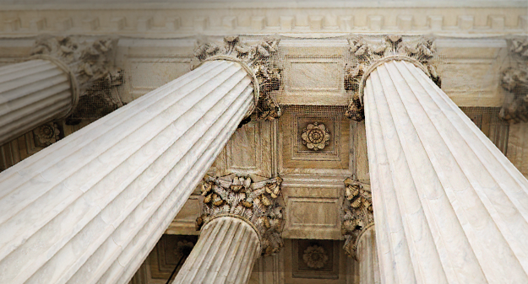

Fig. 1. This figure caption uses the No Indent style, available on the Home tab, in the Styles gallery. Label figures with the abbreviated “Fig.” and a figure number.

The sample Works Cited list that follows starts on its own page. Just type in-text citations as you do any text of your paper. See the sample citation shown at the end of this paragraph. Note also that MLA rules for citations and references are extensive. So it’s a good idea to refer to MLA 7th Edition for further information. (AuthorLastName Pages)

To see this document with all layout and formatting, such as hanging indents, on the View tab, click Reading View. To use this template when creating the outline for your paper, on the Home tab, in the Styles gallery, click No Indent.

For additional guidance on formatting your research paper, consult MLA 7th Edition as well as your instructor.

Works Cited

AuthorLastName, FirstName. Title of the Book Being Referenced. City Name: Name of Publisher, Year. Type of Medium (e.g., Print).

LastName, First, Middle. “Article Title.” Journal Title (Year): Pages From - To. Print.